Hash Table is a data structure that stores data in an associative manner. In a hash table, data is stored in an array format, where each data value has its own unique index value. Access to data becomes very fast if we know the index of the desired data.

Thus, it becomes a data structure in which insertion and search operations are very fast irrespective of the size of the data.

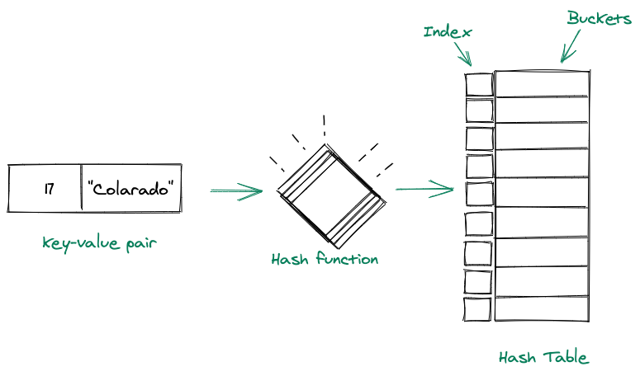

## Components of a Hash Table

A hash table comprises two components in total, these are:

### Hash function:

* A hash function is used to determine the index of the key-value pair.
* A good hash function should be a one-way function, Also, it should avoid producing the same hash for different keys.

### Arrays:

* The array(buckets) are used to hold the key-value pairs.
* The size of the array should be set accordingly to the number of key-value pairs we will have.

## Hash Table: In Hash Tables, we use keys in different ways. We process these keys via a hash function and the result we get from that is basically the location of the bucket where we store our data.

### Collision

When the two different values have the same value, then the problem occurs between the two values, known as a collision. The following are the collision techniques:

**Open Hashing(or closed addressing)** chaining method.

### Closed Hashing (or open addressing)

1. Linear probing
2. Quadratic probing
3. Double Hashing technique

## Handling Collisions in Hash Table

### Linear Probing: It is a technique that makes sure that if we have a collision at a particular bucket, then we check for the next available bucket location(just below it), and insert our data in that bucket.

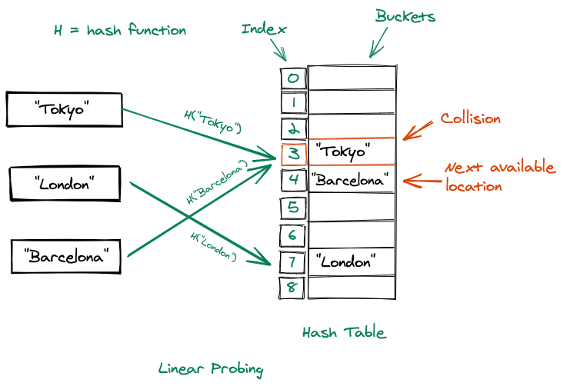

### Quadratic Probing:

In quadratic probing the next bucket location is decided using the formula: h(k, i) = (h?(k) + x*i + y*i^2) where x and y are constants.

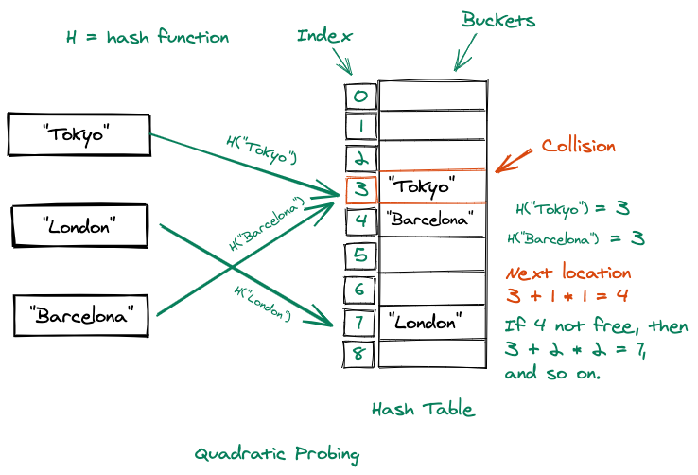

### Chaining: In this technique of collision handling, if at a particular bucket location a collision occurs then at that location we simply create a linked list, and the value will be added as the next node of the list. The Hash table becomes an array of linked list.

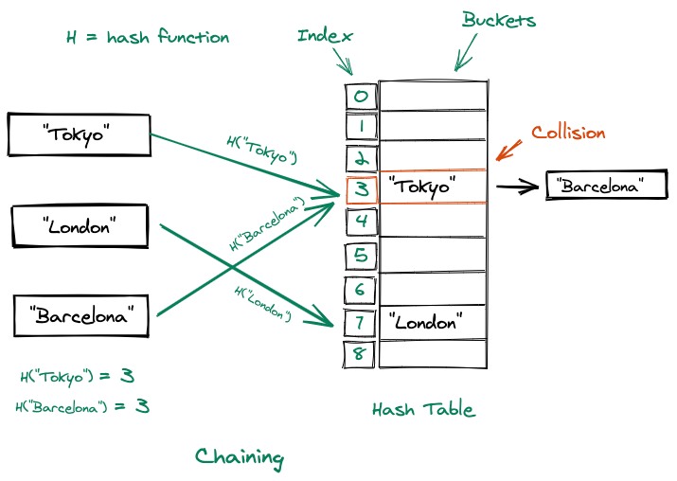

**Double Hashing**

In double hashing, two hash functions are used. It uses one hash value as an index to move forward until the empty location is found. When the collision occurs then this technique uses the secondary hash of the key.

### 